I am sure you will be happy to go through a report on the impact of the solar pump donated by Shakti Pumps (I) Ltd. We are most grateful.
Regards
Bunker Roy
Barefoot College
-----------------------------------------------------------------------------------------------------------------------------------------
REPORT FOR SOLAR OPERATED WATER PUMP AT BAREFOOT COLLEGE
Tilonia, Ajmer District, Rajasthan, INDIA
DONATED BY SHAKTI PUMPS (I) LTD

Project Title: 3 HP Solar Operated Water Pump- 3 Month Report

Location: Barefoot College, Tilonia – Old Campus – between Solar Training Centre and Mess.
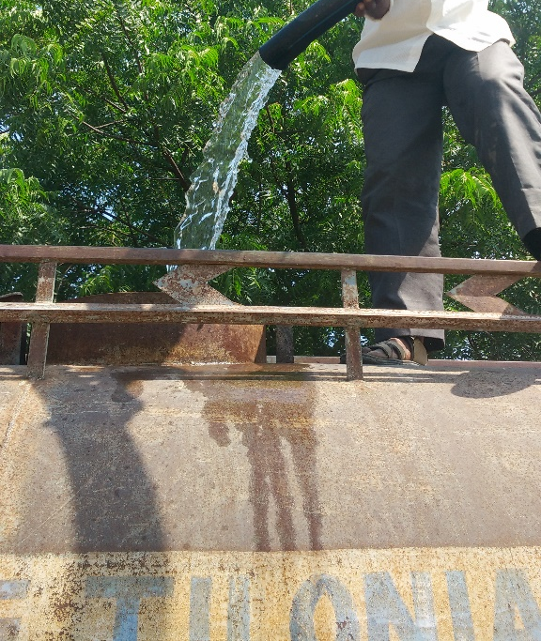

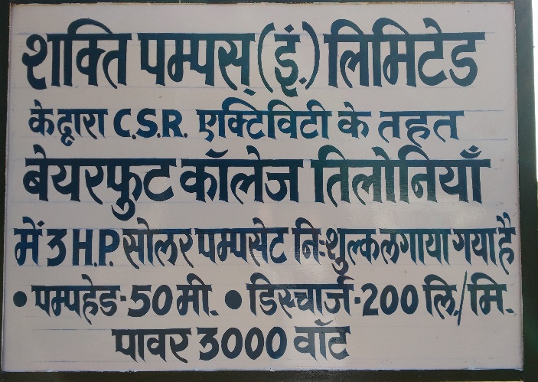
Date of Installation: 5th July, 2016

Donated & Installed by: Shakti Pumps Private Limited

Specifications:
1) Power Consumption: 3 Horse Power (2.24kW)
2) Water Discharge: 200 litres per minute
3) Pump Head: 50 metres
4) No of Solar Panel Strings: 2 nos.

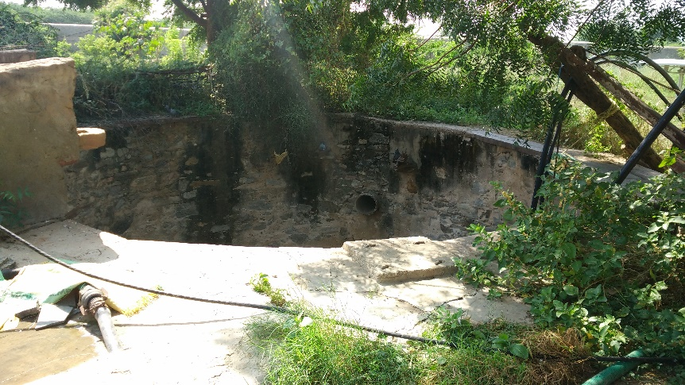
Details of the Well:
1) Depth: 100 feet
2) Diameter: 37 feet
3) Current Depth of Water: 20 Feet
4) Availability of Water: All through the year.
5) Quality of the Water: not safe for drinking
Without treatment
(Flouride: >1.5, TDS: 400-450, hardness :5.4)

Project Justification:

Before:
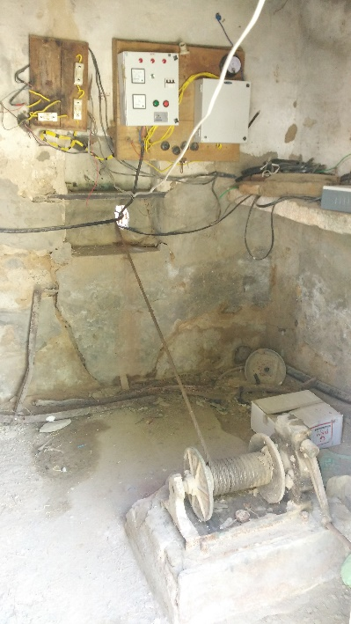
1. Before the Solar Operated Water Pump was installed, a 5 HP Electric Pump was used to pump out water from the well that was inefficient and power hungry. With the frequent power outages, it was highly unreliable, resulting in sourcing water from outside sources.
2. The older 5HP pump was reliant on the grid connection which was unreliable. The uncertainty in power supply meant a shortage of water when needed the most.
3. In times of power outage, water was sourced from external water tankers that charged Rs. 250/ tanker (monsoon and winters) and Rs. 300/ tanker (Summers). This meant that almost Rs. 2,28,000 was spent every year only in supplying water.

Now:
1. The old electric grid operated pump was run for an average of 2-4 hours per day depending on the time of the year. At an average unit cost of Rs. 7 per unit, the pump was incurring a cost of about Rs 38,120 per year.
2. The sun is a reliable and constant source of free energy that is normally going waste when not utilized. With the Solar Operated water pump, we don’t have to depend on the unreliable grid connection. As a result, over the course of the day all the water tanks on the campus are topped up. This ensures that we are able to sustain over the night.
3. In times of power outages especially during the summer months, at a rate of 2-3 tankers per day between both campuses almost Rs.2,28,000 was incurred on procuring water for external sources per year. This enormous cost is now saved.
Number of People Benefitted:
Currently over 800 people work or get trained at the Old Campus. They are the direct beneficiaries from the installation of the Solar operated water pump who combined consume almost 10.5 million litres per year. There is no shortage of water on the campus with drinking water from the R.O Plant and water for sanitation available all through the year.
Solar mama Hostel: Every 6 months a batch size of 40 International Solar mamas supported by the Ministry of External Affairs and 20 Indian Solar Mamas supported by the Ministry of New and Renewable Energy come to Barefoot College to be trained as Women Barefoot Solar Engineers. They are housed in a dormitory style accommodation with separate Lavatory and bath facilities. Water that is pumped out of the well is piped to overhead tanks to be used throughout the day. Approximately 2.2 million litres of water is consumed annually.
Barefoot School: Barefoot’s own school called Shiksha Niketan is housed in a building adjoining the Solar Mama hostel. Here over 400 students studying from Class 1 to Class 8 come to study 6 times a week. The water is transported by Barefoot’s tanker to an underground tank on the school premises and is mainly used for sanitation purposes in the 20 lavatories. Approximately 1.3 million litres of water is consumed annually.
Mess: The mess is where all the Solar mamas, both International and Indian come to dine 3 times a day. In addition, Barefoot College staff working on the campus come to dine here. The building also houses a Reverse Osmosis Water Treatment Plant which provides drinking water not only to the Solar mamas but also the staff living in the Living Quarters which houses 35 families. Approximately 0.5 million litres of water is consumed annually.
Offices: The water pumped out of the well also supplies water to the main training centre where all the Solar mamas are trained. The water is used mostly for Sanitation purposes. Approximately 0.6 million litres of water is consumed annually.
Nursery & Vegetable garden: A vegetable garden and a plant nursery which has many types of plant and tree varieties is located right behind the Mess Block. 50 kilograms of maize crop was given to the mess this harvest season, with the sesame seeds currently being harvested. About 20-25 kilograms of vegetables such as Spinach, fenugreek, various gourds, lemon and green chilies will be supplied to the mess by early next year. Although the vegetable garden relies mostly on the waste water from the mess, a certain portion of the nursery is connected to a drip irrigation system which sources water from the solar Pump. Approximately 1.5 million litres of water is consumed annually.
New Campus: The Water drawn from the tube well not only takes cares of the needs of the campus it is located on but 4-5 tanker loads of water are brought to the New campus per day to fill up the underground tanks. A tanker (shown below) supplies the guest house, Mess, staff quarters and the dormitories, with the count going up in summers when the coolers are in operation. Approximately 4.4 million litres of water is consumed annually.
